**Assignment 2**

pwd - print name of current/working directory

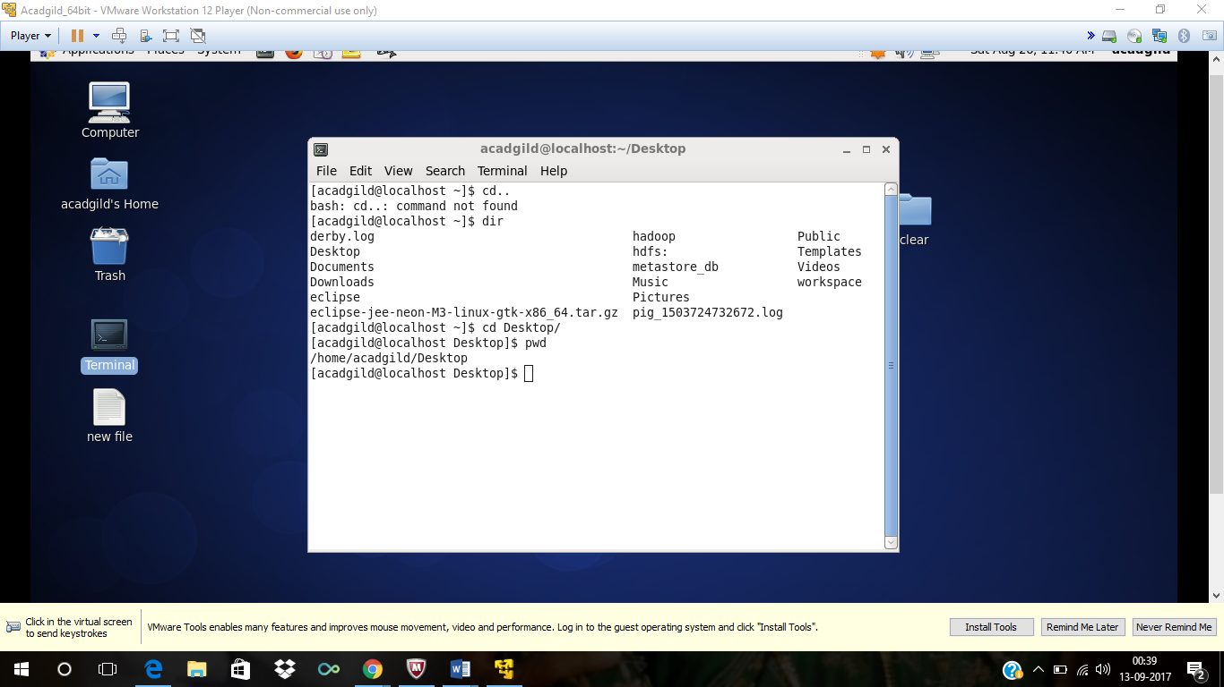

**Vi - vi filename**

Creates a new file if it already does not exist, otherwise opens an existing file.

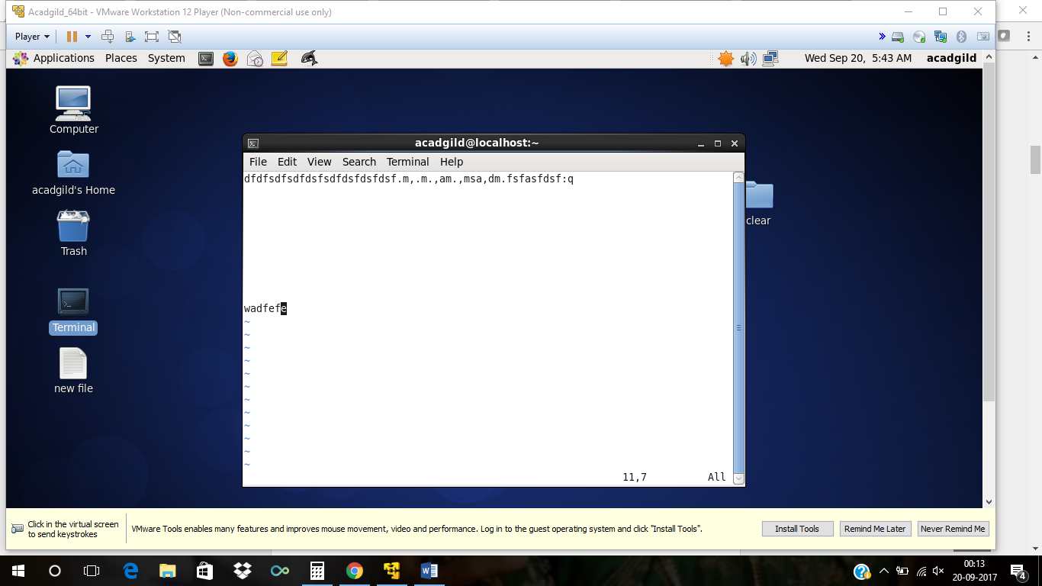

**Touch**

To create an empty file using the touch command pass the name of the file to be created to the touch command. This sets the access and modification time for the file to the current time when running the command.

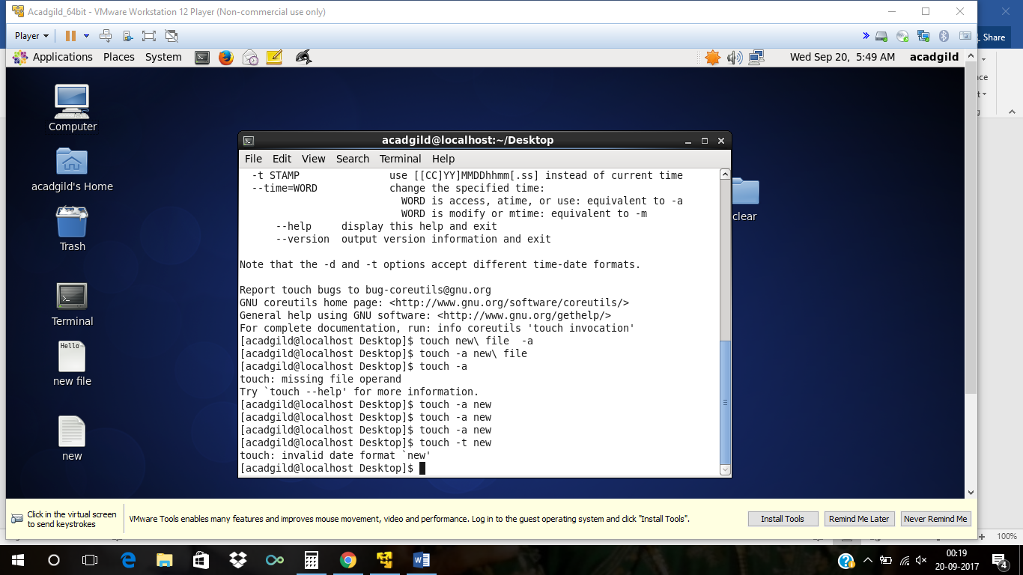

**Mkdir**

he **mkdir** command creates a single directories or multiple directories.

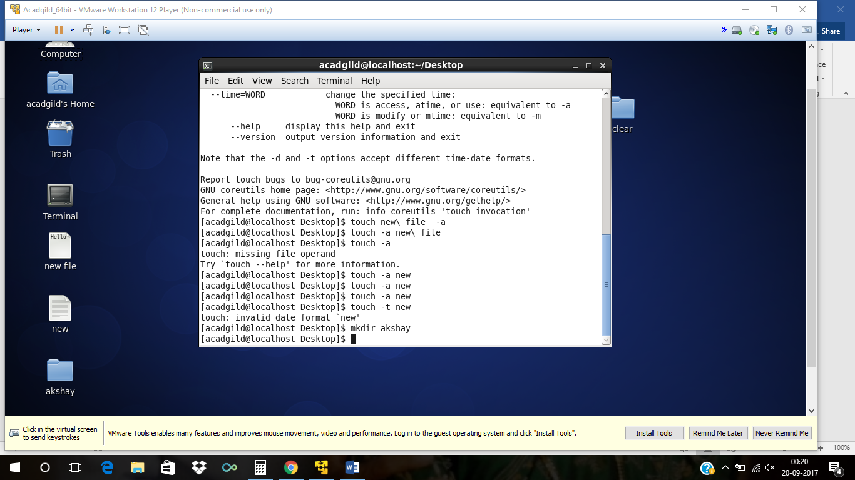

**Rm**

The **rm** command removes ([deletes](https://www.computerhope.com/jargon/d/delete.htm)) [files](https://www.computerhope.com/jargon/f/file.htm) or [directories](https://www.computerhope.com/jargon/d/director.htm).

**Is**

**List directories**

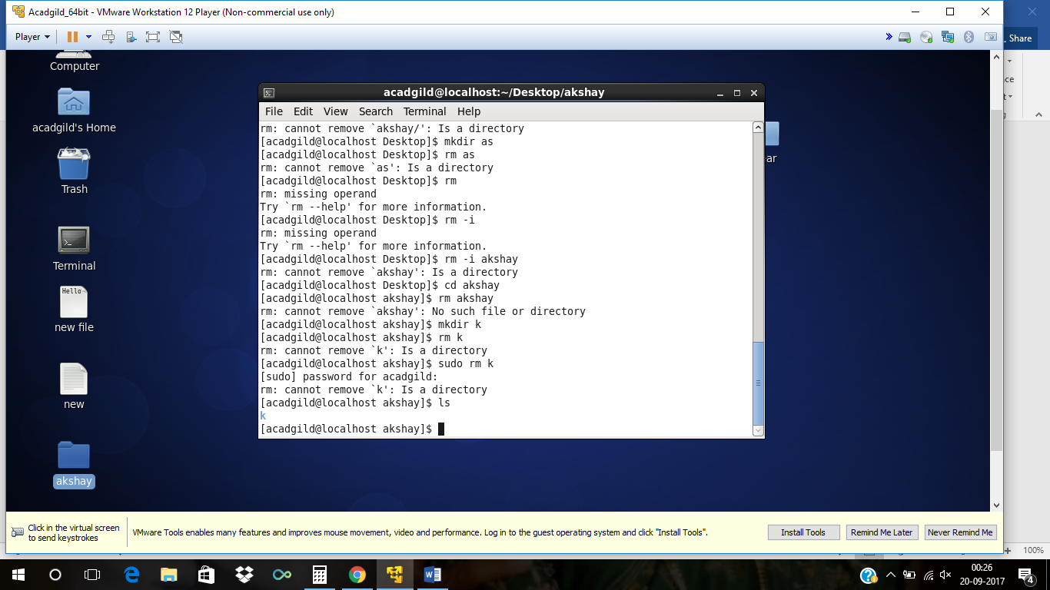

**Echo** - display a line of text.

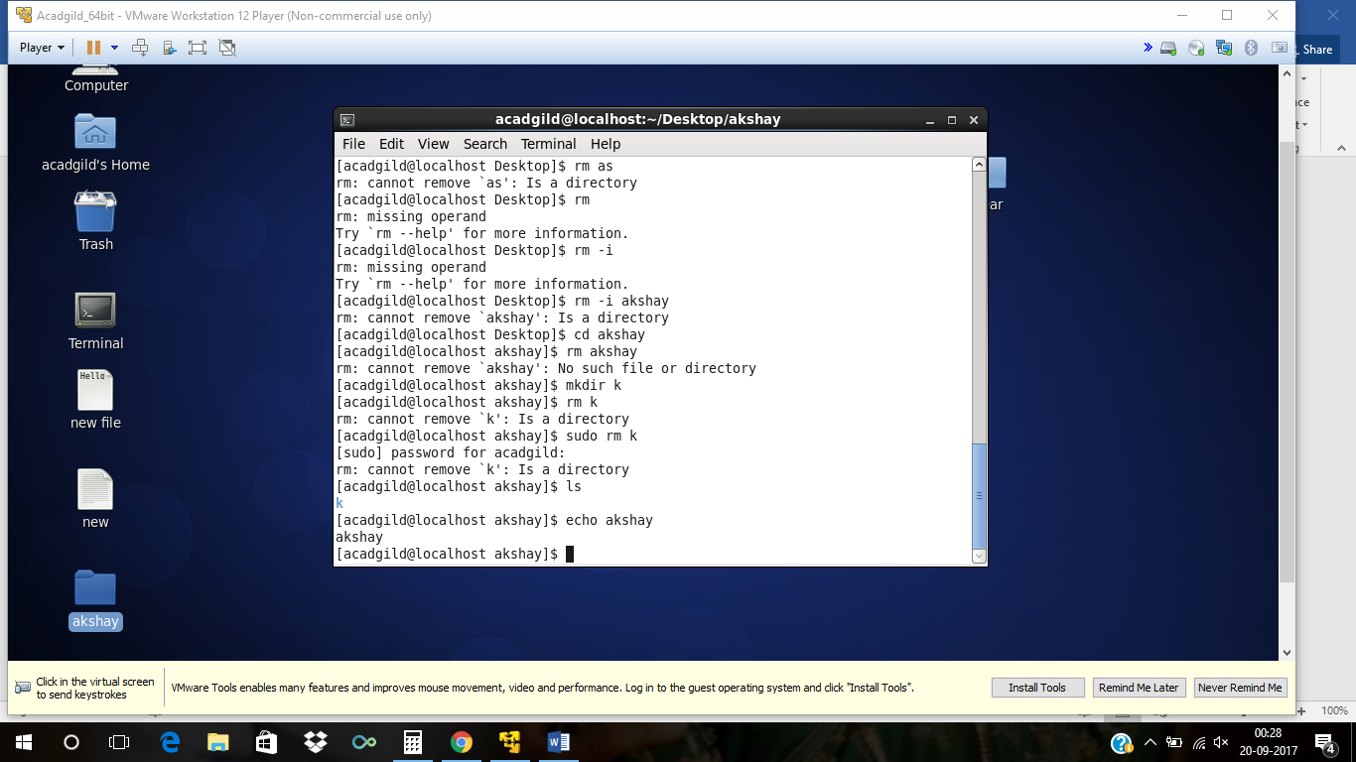

**Cat -** The **cat** command reads one or more files and prints their contents to standard output. Files are read and output in the order they appear in the command arguments.

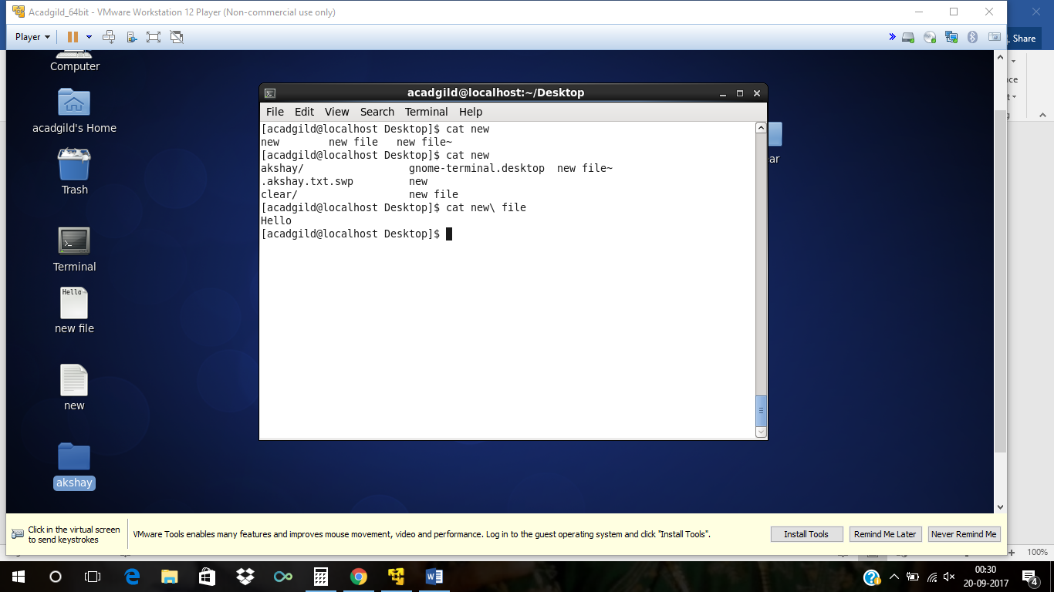

**Who**

The standard **Unix** command who displays a list of users who are currently logged into the computer. The who command is related to the command w, which provides the same information but also displays additional data and statistics.

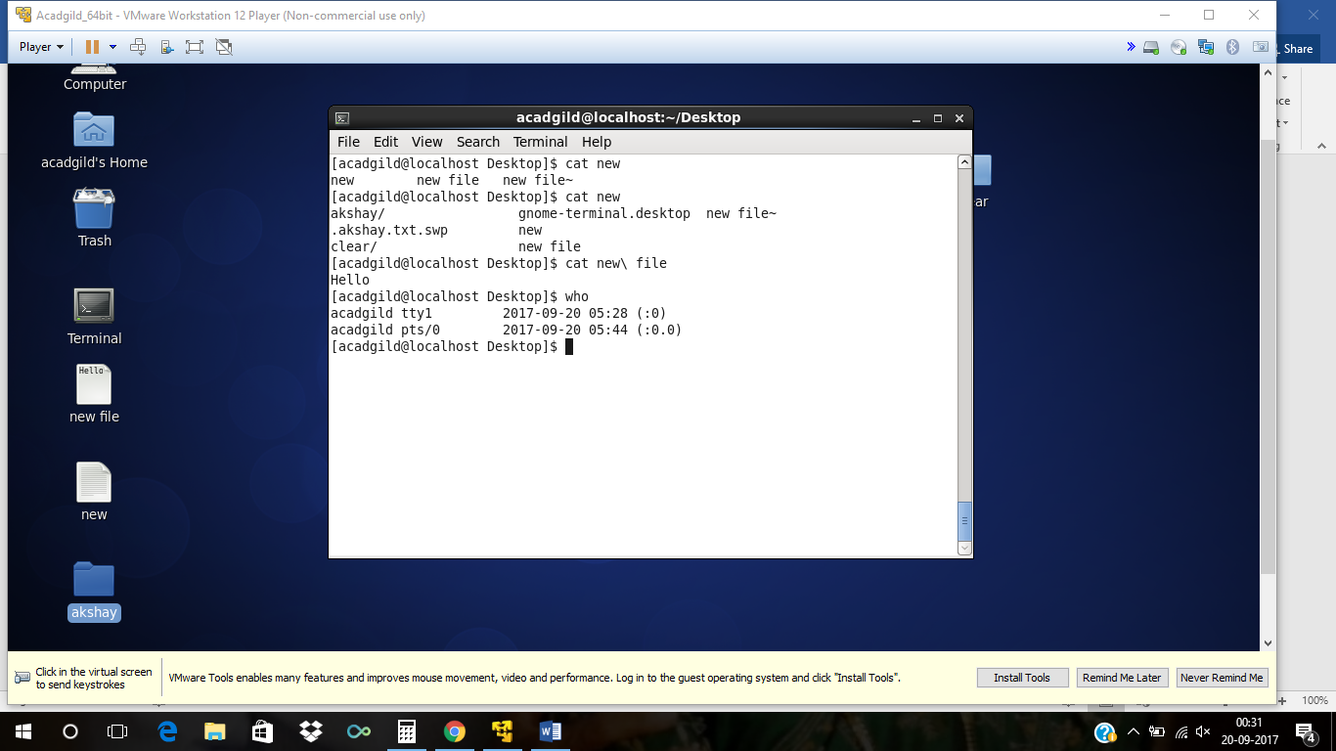

**Cd** The **cd** command, also known as chdir (**change directory**), is a command-line OS shell command used to change the current working directory in operating systems

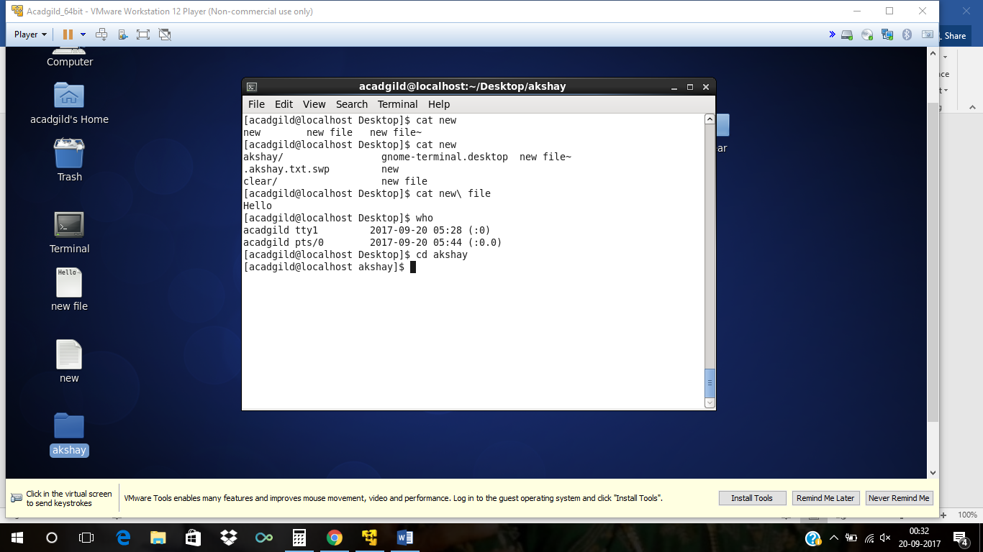**date**

Display date

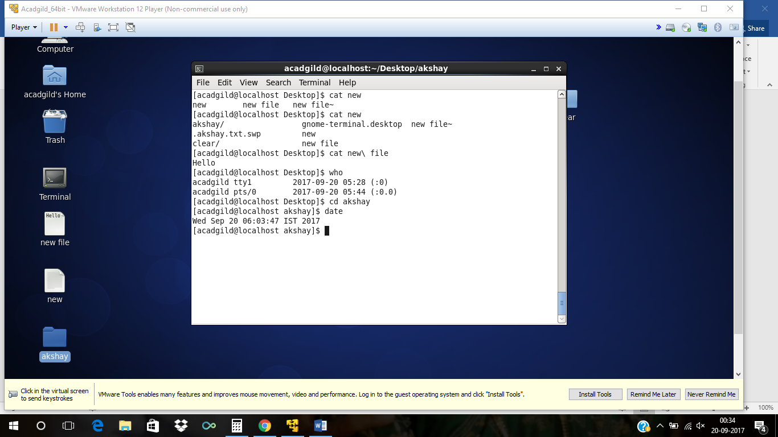

**Cal**

The **cal command** is a **command** line utility for displaying a calendar in the terminal. It can be used to print a single month, many months or an entire year. It supports starting the week on a Monday or a Sunday, showing Julian dates and showing calendars for arbitrary dates passed as argument

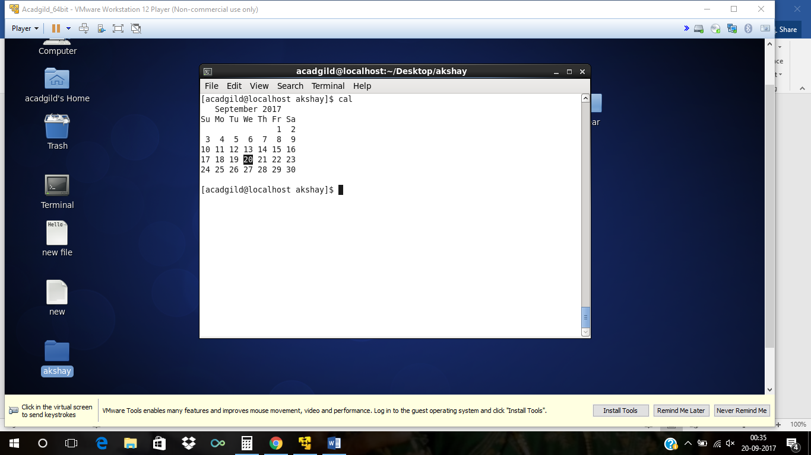

**Mv** The **mv command** is used to move or rename files.

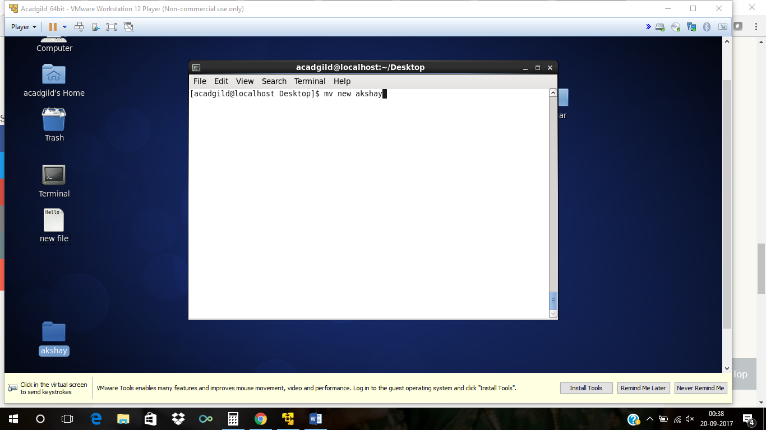

**Cp**

The **cp** command is used to make copies of files and directories.

**Which**

which is a **Unix** command used to identify the location of executables. The command takes one or more arguments; for each of these arguments, it prints the full path of the executable to stdout that would have been executed if this argument had been entered into the shell.